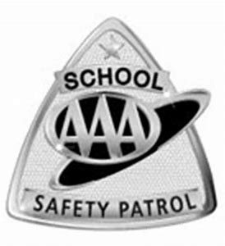

Thacker Avenue Elementary School for International Studies Safety Patrol

Our Safety Patrol volunteers are applicants from the 5th grade.
Safety Patrols model the positive behavior we expect from all students.
Our SRO, Officer Morris, speaks about safety with our patrols.
If you are a 5th grade looking to become a patrol, please see Ms. Valero or Officer Morris for an application.
In the spring, 4th graders are given the opportunity to apply for the next school year.

The Safety Patrol will meet monthly at 7:30 am in the cafeteria.
Dates for the 2023-2024 school year:
8/10
9/6
10/11
11/8
12/8 Winter Breakfast
1/10
2/7
3/6
4/10
5/24 End of Year Celebration
Please contact Marie Valero or Officer Morris for more information.
Marie.protanovalero@osceolaschools.net
Rebekah.morris@osceolaschools.net

